Lab Taks-2

Submission Guidelines-
- Rename the file with your serial number only.
- Must include resources for all the section in the table
Question- 1 Draw the following figure

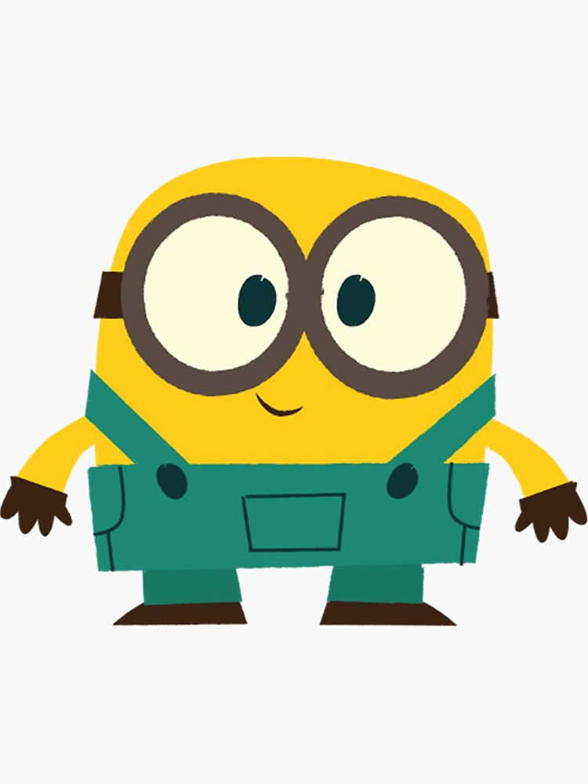

Graph Plot (Picture)-
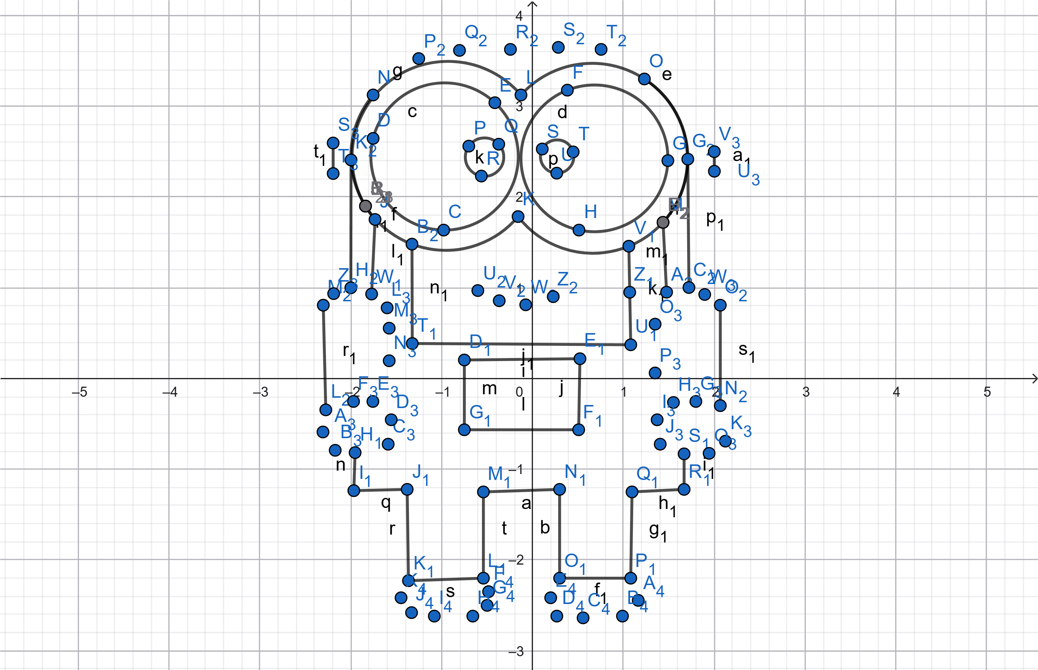

Code-

#include <GL/glut.h>
#include <math.h>
#define PI 3.14159265358979323846

// filled circle
void draw_circle(float cx, float cy, float r) {
int num_segments = 100;
glBegin(GL_TRIANGLE_FAN);
glVertex2f(cx, cy);
for (int i = 0; i <= num_segments; i++) {
float theta = i * (2.0f * PI / num_segments);
float x = cx + r * cosf(theta);
float y = cy + r * sinf(theta);
glVertex2f(x, y);
}
glEnd();
}

// filled rectangle
void draw_rectangle(float x, float y, float width, float height) {
glBegin(GL_QUADS);
glVertex2f(x, y);
glVertex2f(x + width, y);
glVertex2f(x + width, y + height);
glVertex2f(x, y + height);
glEnd();
}

// rectangle border (no fill)
void draw_rectangle_border(float x, float y, float width, float height, float lineWidth) {
glLineWidth(lineWidth);
glBegin(GL_LINE_LOOP);
glVertex2f(x, y);
glVertex2f(x + width, y);
glVertex2f(x + width, y + height);
glVertex2f(x, y + height);
glEnd();
}

// rounded rectangle
void draw_rounded_rectangle(float x, float y, float width, float height, float radius) {
draw_rectangle(x + radius, y, width - 2 * radius, height);
draw_rectangle(x, y + radius, width, height - 2 * radius);
draw_circle(x + radius, y + radius, radius);
draw_circle(x + width - radius, y + radius, radius);
draw_circle(x + radius, y + height - radius, radius);
draw_circle(x + width - radius, y + height - radius, radius);
}

void drawMinion() {
glClear(GL_COLOR_BUFFER_BIT);

// Body
glColor3f(0.988f, 0.878f, 0.161f);
float bodyWidth = 0.45f;
float bodyHeight = 0.6f;
float bodyX = -bodyWidth / 2.0f;
float bodyY = -0.3f;
float bodyRadius = 0.15f;
draw_rounded_rectangle(bodyX, bodyY, bodyWidth, bodyHeight, bodyRadius);

// Overalls
glColor3f(0.2f, 0.6f, 0.5f);
float overallsWidth = 0.45f;
float overallsHeight = 0.2f;
float overallsX = -overallsWidth / 2.0f;
float overallsY = bodyY;
draw_rectangle(overallsX, overallsY, overallsWidth, overallsHeight);

// Pocket
float pocketWidth = 0.16f;
float pocketHeight = 0.10f;
float pocketX = -pocketWidth / 2.0f;
float pocketY = overallsY + 0.08f;
glColor3f(0.2f, 0.6f, 0.5f);
draw_rectangle(pocketX, pocketY, pocketWidth, pocketHeight);
glColor3f(0.0f, 0.0f, 0.0f);
draw_rectangle_border(pocketX, pocketY, pocketWidth, pocketHeight, 2.0f);

// Straps
glColor3f(0.2f, 0.6f, 0.5f);
float strapWidth = 0.05f;
float strapHeight = 0.25f;
draw_rectangle(-0.2f, -0.10f, strapWidth, strapHeight);
draw_rectangle(0.15f, -0.10f, strapWidth, strapHeight);

// Buttons
glColor3f(0.0f, 0.0f, 0.0f);
float buttonYOffset = -0.12f; // shift buttons downward
draw_circle(-0.2f + strapWidth / 2.0f, (-0.10f + strapHeight / 2.0f) + buttonYOffset, 0.012f);
draw_circle(0.15f + strapWidth / 2.0f, (-0.10f + strapHeight / 2.0f) + buttonYOffset, 0.012f);

// Goggles strap
glColor3f(0.659f, 0.478f, 0.318f);
float goggleStrapWidth = bodyWidth + 0.05f;
float goggleStrapHeight = 0.04f;
float goggleY = bodyY + bodyHeight * 0.72f;
draw_rectangle(-goggleStrapWidth / 2.0f, goggleY, goggleStrapWidth, goggleStrapHeight);

// goggles
glColor3f(0.58f, 0.588f, 0.6f);
float goggleRadius = 0.13f;
float eyeCenterY = goggleY + goggleStrapHeight / 2.0f;
draw_circle(-0.1f, eyeCenterY, goggleRadius);
draw_circle(0.1f, eyeCenterY, goggleRadius);

// eyes
glColor3f(1.0f, 1.0f, 1.0f);
float eyeRadius = 0.10f;
draw_circle(-0.1f, eyeCenterY, eyeRadius);
draw_circle(0.1f, eyeCenterY, eyeRadius);

// pupils
glColor3f(0.0f, 0.0f, 0.0f);
float pupilRadius = 0.025f;
draw_circle(-0.05f, eyeCenterY, pupilRadius);
draw_circle(0.05f, eyeCenterY, pupilRadius);

// Mouth
glColor3f(0.0f, 0.0f, 0.0f);
glLineWidth(2.0f);
glBegin(GL_LINE_STRIP);
float mouthWidth = 0.12f;
float mouthHeight = 0.02f;
for (int i = 0; i <= 30; i++) {
float t = (float)i / 30.0f;
float x = -mouthWidth / 2.0f + mouthWidth * t;
float y = bodyY + 0.27f - mouthHeight * sinf(PI * t);
glVertex2f(x, y);
}
glEnd();

// Arms
glColor3f(0.988f, 0.878f, 0.161f);
draw_rounded_rectangle(-0.27f, -0.25f, 0.09f, 0.22f, 0.03f);
draw_rounded_rectangle(0.18f, -0.25f, 0.09f, 0.22f, 0.03f);

// Hands (Brown)
glColor3f(0.4f, 0.2f, 0.0f);
draw_rounded_rectangle(-0.27f, -0.25f, 0.10f, 0.07f, 0.03f);
draw_rounded_rectangle(0.18f, -0.25f, 0.10f, 0.07f, 0.03f);

// Legs (Teal-blue fill)
glColor3f(0.2f, 0.6f, 0.5f);
draw_rectangle(-0.15f, bodyY - 0.00f, 0.10f, -0.15f); // Left leg
draw_rectangle(0.05f, bodyY - 0.00f, 0.10f, -0.15f); // Right leg

// Shoes
glColor3f(0.4f, 0.2f, 0.0f);
draw_rounded_rectangle(-0.16f, bodyY - 0.17f, 0.12f, 0.05f, 0.02f);
draw_rounded_rectangle(0.04f, bodyY - 0.17f, 0.12f, 0.05f, 0.02f);

glFlush();
}

void init() {
glClearColor(1.0f, 1.0f, 1.0f, 1.0f);
glMatrixMode(GL_PROJECTION);
gluOrtho2D(-0.5f, 0.5f, -0.5f, 0.5f);
}

int main(int argc, char** argv) {
glutInit(&argc, argv);
glutInitDisplayMode(GLUT_SINGLE | GLUT_RGB);
glutInitWindowSize(600, 600);
glutCreateWindow("Minion");
init();
glutDisplayFunc(drawMinion);
glutMainLoop();
return 0;
}
Output Screenshot (Full Screen)-

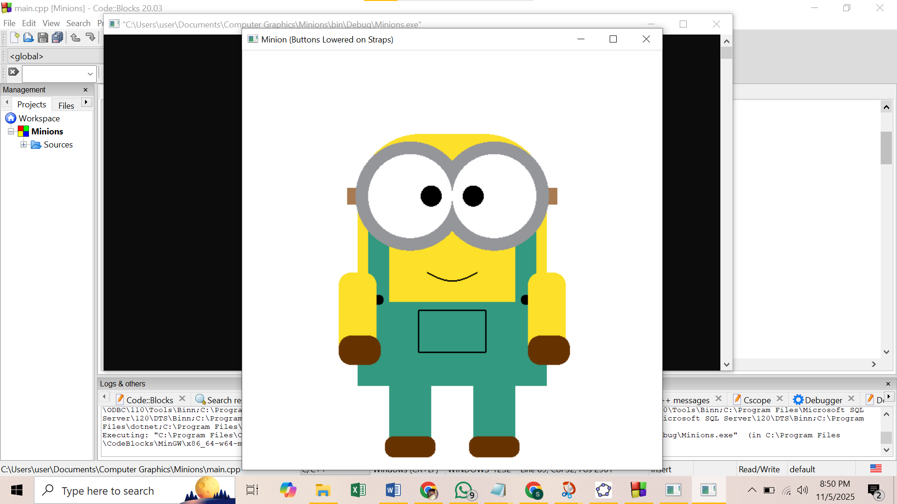

Question- 2

Draw 4X4 Chess Board

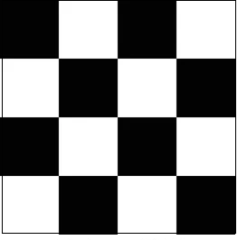

Graph Plot (Picture)-

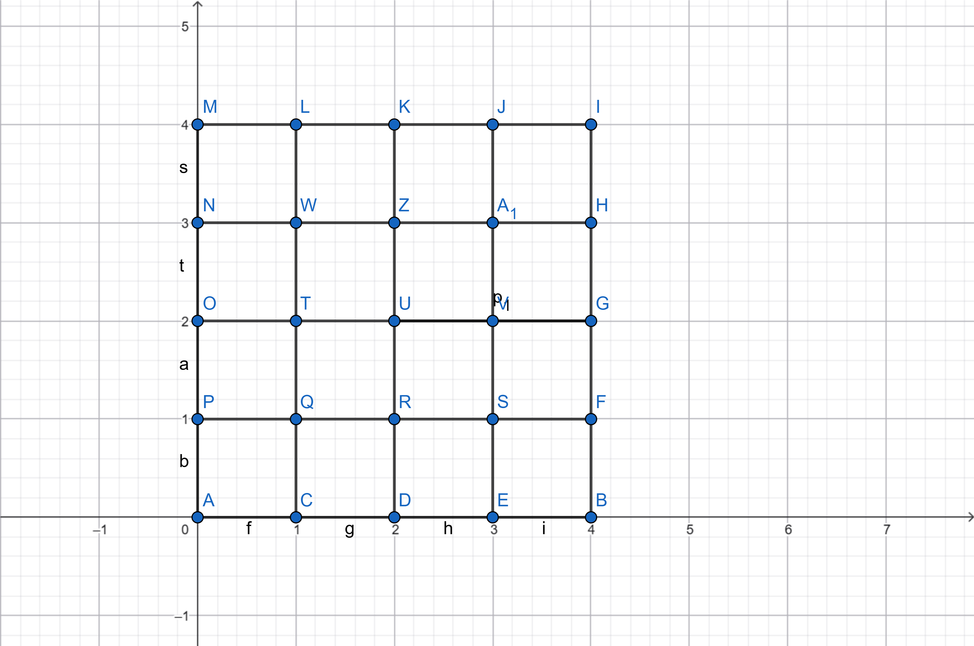
Code-
#include <GL/glut.h>

void drawSquare(int x, int y, float r, float g, float b)
{
int size = 80; // size of each square
glColor3f(r, g, b);
glBegin(GL_QUADS);
glVertex2i(x * size, y * size);
glVertex2i(x * size+size, y * size);
glVertex2i(x * size+size, y * size+size);
glVertex2i(x * size, y * size+size);
glEnd();
}

void myDisplay()
{
glClear(GL_COLOR_BUFFER_BIT);

for(int row = 0; row < 4; row++)
{
for(int col = 0; col < 4; col++)
{
if((row + col) % 2 == 0)
drawSquare(col, row, 1.0, 1.0, 1.0); // White
else
drawSquare(col, row, 0.0, 0.0, 0.0); // Black
}
}

glFlush();
}

void myInit()
{
glClearColor(1.0, 1.0, 1.0, 0.0);
glMatrixMode(GL_MODELVIEW);
glLoadIdentity();
gluOrtho2D(0.0, 320.0, 0.0, 320.0); // 4×80 = 320
}

int main(int argc, char** argv)
{
glutInit(&argc, argv);
glutInitDisplayMode(GLUT_SINGLE | GLUT_RGB);
glutInitWindowSize(320, 320);
glutInitWindowPosition(100, 100);
glutCreateWindow("4x4 Chess Board");
glutDisplayFunc(myDisplay);
myInit();
glutMainLoop();
return 0;
}

Output Screenshot (Full Screen)-
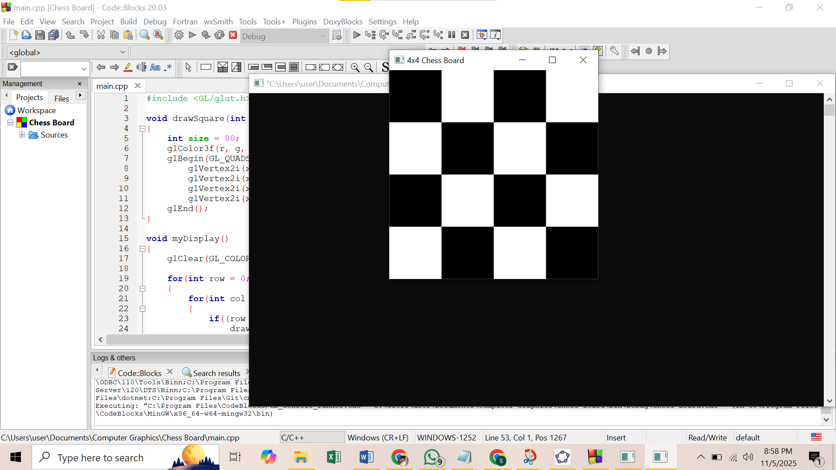

Question- 3

Create the batman logo given below-
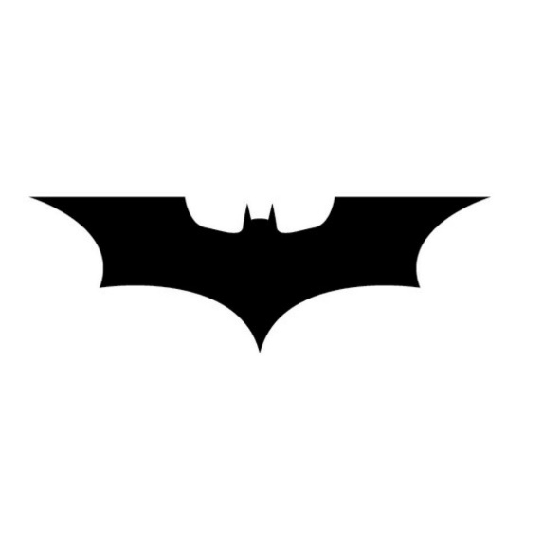

Graph Plot (Picture)-
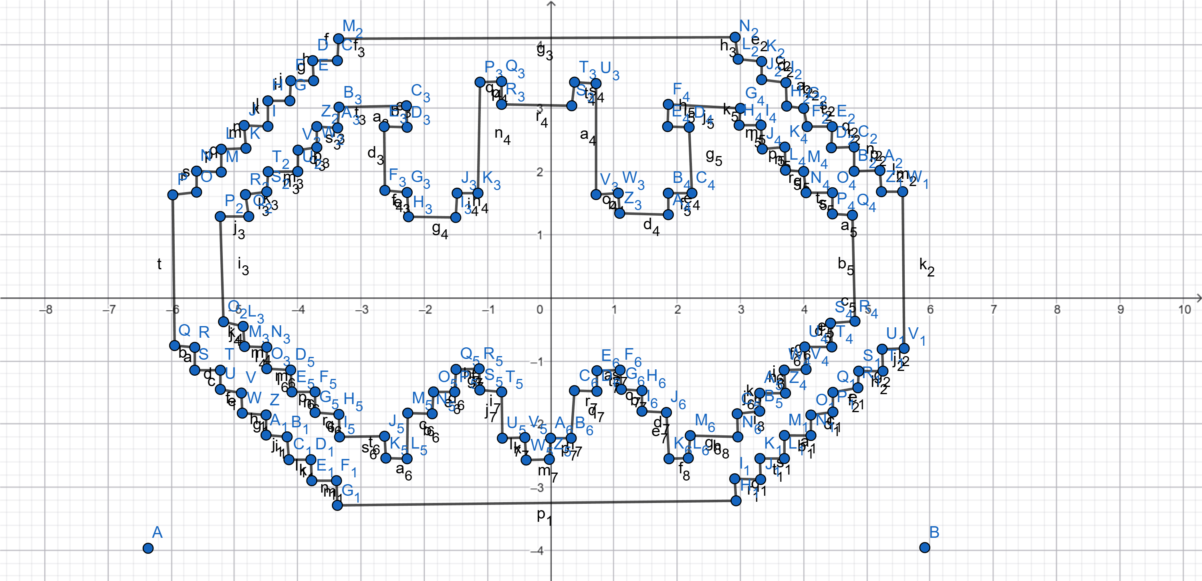

Code-
#include <GL/gl.h>
#include <GL/glut.h>

void quad(int i, int y, float r, float g, float b)
{
int x = 20;
glColor3f(r, g, b);
glBegin(GL_QUADS);
glVertex2i(i*x, y*x);
glVertex2i(i*x+20,y*x);
glVertex2i(i*x+20,y*x+20);
glVertex2i(i*x, y*x+20);
glEnd();
}

void myDisplay()
{
glClear(GL_COLOR_BUFFER_BIT);

int x = 20;
int y;

// Row y = 2
y = 2;
for(int i=8;i<=24;i++) quad(i,y,0,0,0);

// Row y = 3
y = 3;
quad(7,y,0,0,0); quad(25,y,0,0,0);
for(int i=8;i<=24;i++) quad(i,y,1,1,1);

// Row y = 4
y = 4;
for(int i=7;i<=25;i++) quad(i,y,1,1,1);
quad(6,y,0,0,0); quad(26,y,0,0,0);
quad(10,y,0,0,0); quad(22,y,0,0,0); quad(16,y,0,0,0);

// Row y = 5
y = 5;
for(int i=6;i<=26;i++) quad(i,y,1,1,1);
quad(5,y,0,0,0); quad(27,y,0,0,0);
for(int i=8;i<=10;i++) quad(i,y,0,0,0);
for(int i=22;i<=24;i++) quad(i,y,0,0,0);
for(int i=15;i<=17;i++) quad(i,y,0,0,0);

// Row y = 6
y = 6;
for(int i=5;i<=27;i++) quad(i,y,1,1,1);
quad(4,y,0,0,0); quad(28,y,0,0,0);
for(int i=7;i<=11;i++) quad(i,y,0,0,0);
for(int i=21;i<=25;i++) quad(i,y,0,0,0);
for(int i=15;i<=17;i++) quad(i,y,0,0,0);

// Row y = 7
y = 7;
for(int i=4;i<=28;i++) quad(i,y,1,1,1);
quad(3,y,0,0,0); quad(29,y,0,0,0);
for(int i=6;i<=12;i++) quad(i,y,0,0,0);
for(int i=20;i<=26;i++) quad(i,y,0,0,0);
for(int i=14;i<=18;i++) quad(i,y,0,0,0);

// Row y = 8
y = 8;
for(int i=3;i<=29;i++) quad(i,y,1,1,1);
quad(2,y,0,0,0); quad(30,y,0,0,0);
for(int i=5;i<=27;i++) quad(i,y,0,0,0);

// Row y = 9
y = 9;
for(int i=2;i<=30;i++) quad(i,y,1,1,1);
quad(1,y,0,0,0); quad(31,y,0,0,0);
for(int i=4;i<=28;i++) quad(i,y,0,0,0);

// Rows y = 10 to 14
for(y=10;y<=14;y++)
{
for(int i=2;i<=30;i++) quad(i,y,1,1,1);
quad(1,y,0,0,0); quad(31,y,0,0,0);
for(int i=3;i<=29;i++) quad(i,y,0,0,0);
}

// Row y = 15
y = 15;
for(int i=2;i<=30;i++) quad(i,y,1,1,1);
quad(1,y,0,0,0); quad(31,y,0,0,0);
for(int i=4;i<=10;i++) quad(i,y,0,0,0);
for(int i=13;i<=19;i++) quad(i,y,0,0,0);
for(int i=22;i<=28;i++) quad(i,y,0,0,0);

// Row y = 16
y = 16;
for(int i=3;i<=29;i++) quad(i,y,1,1,1);
quad(2,y,0,0,0); quad(30,y,0,0,0);
for(int i=5;i<=9;i++) quad(i,y,0,0,0);
for(int i=14;i<=18;i++) quad(i,y,0,0,0);
for(int i=23;i<=27;i++) quad(i,y,0,0,0);

// Row y = 17
y = 17;
for(int i=4;i<=28;i++) quad(i,y,1,1,1);
quad(3,y,0,0,0); quad(29,y,0,0,0);
for(int i=6;i<=9;i++) quad(i,y,0,0,0);
for(int i=14;i<=18;i++) quad(i,y,0,0,0);
for(int i=23;i<=26;i++) quad(i,y,0,0,0);

// Row y = 18
y = 18;
for(int i=5;i<=27;i++) quad(i,y,1,1,1);
quad(4,y,0,0,0); quad(28,y,0,0,0);
for(int i=7;i<=9;i++) quad(i,y,0,0,0);
for(int i=14;i<=18;i++) quad(i,y,0,0,0);
for(int i=23;i<=25;i++) quad(i,y,0,0,0);

// Row y = 19
y = 19;
for(int i=6;i<=26;i++) quad(i,y,1,1,1);
quad(5,y,0,0,0); quad(27,y,0,0,0);
for(int i=8;i<=10;i++) quad(i,y,0,0,0);
for(int i=14;i<=18;i++) quad(i,y,0,0,0);
for(int i=22;i<=24;i++) quad(i,y,0,0,0);

// Row y = 20
y = 20;
for(int i=7;i<=25;i++) quad(i,y,1,1,1);
quad(6,y,0,0,0); quad(26,y,0,0,0);
quad(14,y,0,0,0); quad(18,y,0,0,0);

// Row y = 21
y = 21;
quad(7,y,0,0,0); quad(25,y,0,0,0);
for(int i=8;i<=24;i++) quad(i,y,1,1,1);

// Row y = 22 (final black bar)
y = 22;
for(int i=8;i<=24;i++) quad(i,y,0,0,0);

quad(3,3,1,1,1);
quad(29,3,1,1,1);
quad(3,21,1,1,1);
quad(29,21,1,1,1);

glFlush();
}

void myInit ()
{
glClearColor(1,1,1,0);
glMatrixMode(GL_MODELVIEW);
glLoadIdentity();
gluOrtho2D(0.0, 660.0, 0.0, 480.0);
}

int main(int argc, char** argv)
{
glutInit(&argc, argv);
glutInitDisplayMode (GLUT_SINGLE | GLUT_RGB);
glutInitWindowSize (700, 480);
glutInitWindowPosition (0, 0);
glutCreateWindow ("Batman logo");
glutDisplayFunc(myDisplay);
myInit ();
glutMainLoop();
return 0;
}

Output Screenshot (Full Screen)-

